**Team 7**

**Ratheeban Rajakumar**

**Yves Chapuis**

**Roman Alonzo**

**Roland Tschendel**

**Michael Monteiro**

**Software Requirements Specification**

**Document**

**Version: (1.8.3)** **Date: (11/22/17)**

Content

1. Introduction 3

1.1 Purpose 3

1.2 Scope 3

1.3 System Overview 3

1.4 Stakeholders 3

1.5 Definitions 3

2. The Overall Description 3

2.1 Product Perspective 4

2.1.2 System Interfaces 4

2.1.3 User Interfaces 4

2.1.5 Software Interfaces 4

2.1.6 Communications Interfaces 4

2.1.7 Memory Constraints 4

2.2 Design Constraints 4

2.2.1 Operations 5

2.2.2 Standards Compliance 5

2.3 Product Functions 5

2.4 User Characteristics 6

2.5 Constraints assumptions and dependencies 7

3. Specific requirements 7

3.1 External Interface Requirements 7

3.2 Functional Requirements 7

4. Non Functional Requirements 8

4.0 User Interface 8

4.1 Performance Requirements 8

4.2 Logical Database Requirements 8

4.3 Software System Attributes 10

4.3.2 Availability 10

4.3.3 Security 11

4.3.4 Maintainability 11

4.3.5 Portability 11

4.3.6 Usability 11

# 1. Introduction

## 1.1 Purpose

The purpose of this SRS is to describe the requirements for the logistics tool programmed for the aniTrans company during the ESE course at the University of Berne in the autumn-semester 2017.

It is intended for aniTrans and team seven.

## 1.2 Scope

Our app will provide the logisticians of aniTrans the means to plan tours for their drivers. The drivers will be able to see their tours. The system will also be able to track the individual deliveries inside the tour, so that the driver can mark them as ‘delivered’ or ‘not delivered’ if the recipient isn’t home and add a comment.

The purpose is to make life easier for aniTrans, which have up to now been writing everything on paper.

## 1.3 System Overview

The SRS will contain first a general description of the project and then the specifications, which are intended mainly for the team and not the customer. There we will make technical definitions which are only relevant to us.

## 1.4 Stakeholders

The main stakeholder of aniTrans for this app is the managing director.

## 1.5 Definitions

* aniTrans: Animal Transportation company
* Spring Framework: a programming and configuration model for modern Java-based enterprise applications
* SRS: software requirements specification

# 2. The Overall Description

The application will be a web-application to manage the logistics of aniTrans, which is a company that transports animals.

After logging in, the logisticians will be able to plan tours for their drivers. The tours can be sorted by status (successful & unsuccessful).

A Car pool list gives an overview of all trucks which are available.

If a tour/order is created, it should be possible to assign a car. Take the truck out of the carpool list (i.e. from the available trucks)

If the route is finished put this car again in the carpool list.

The drivers will be able to create an account and log in to see their tours for the next few days. Once on a tour they can mark individual deliveries as delivered or not delivered and add a comment. The app will also be able to keep track of how long specific tours will take, so that the logisticians will be able to adjust and correct their time estimates.

## 2.1 Product Perspective

### 2.1.2 System Interfaces

This will be a self-contained web-application, so the interface will consist of a graphical website. The website will contain images and texts to provide information to the user. To interact with the application there will be forms for login, creating and managing orders and tours, etc.

### 2.1.3 User Interfaces

The webpage with certain forms and tables (add/edit/view orders, change status, view tours, view drivers, register, login, view vehicles, add vehicle type, add/remove vehicle) and the homepage.

### 2.1.5 Software Interfaces

The web app will use a MySQL database to store information.

A web server needs to be installed to run the website.

The customer needs a web browser.

### 2.1.6 Communications Interfaces

Thymeleaf is used to communicate between html forms and sites and the java code of the web-application running behind the website.

Spring Data JPA is used to communicate with the MySQL database.

### 2.1.7 Memory Constraints

Standard Business PC requirements...

## 2.2 Design Constraints

### 2.2.1 Operations

Version 2

We must be able to interface with any html browser.

Out of scope

* The new version of the spreadsheet must be able to access data from the previous two versions.
* The product shall be able to be installed by an untrained user without recourse to separately-printed instructions

### 2.2.2 Standards Compliance

We don’t have any standards we have to conform to.

## 2.3 Product Functions

## 

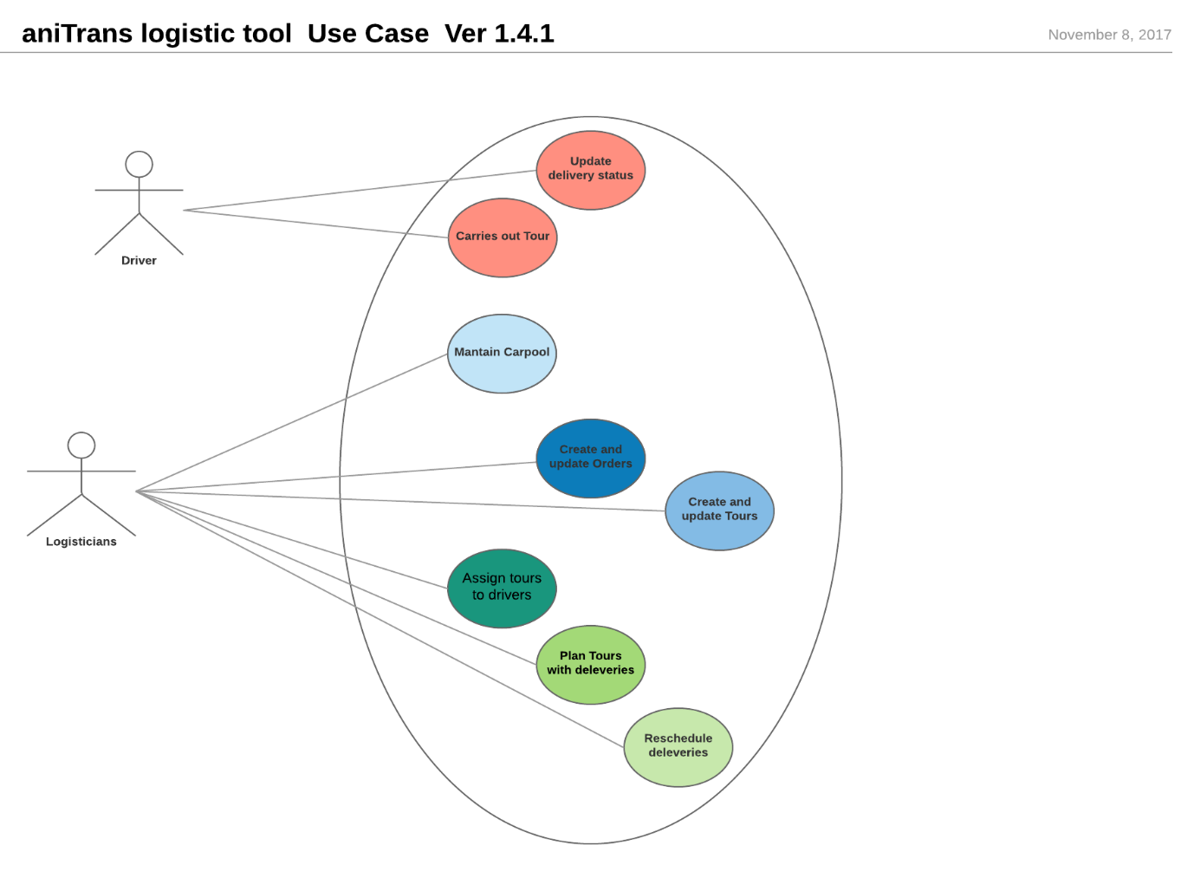

* + Logisticians Log in
    - Plan tours with individual deliveries
    - See which deliveries were delivered and which were not
    - Reschedule undelivered deliveries for another day
    - Keep track of how much off the time estimate was on past tours
    - Assign tours to drivers
  + Drivers create an account and log in.
    - See the tours for the next few days

## 2.4 User Characteristics

General Preconditions

User has access to the internet, a working computer or smartphone.

User Characteristics

**Standard Users**: Ability to read English, able to register an account, able to navigate website pages.

**Logisticians**: In addition to Standard User capabilities, they need to fill out order forms, and manage a database.

**Driver** (standard) **Use Cases**

**Description**: Is able to see order-specific data, and should be able to change information. Should be able to change statuses.   
They cannot see Orders, Vehicles or Drivers pages.

**Pre-condition**: Should be logged in as a driver.

**Post-condition**: Order status changed.

**Main scenario**:

* Logs in.
* Navigates to tours.
* Reads tour information and carries it out.
* Depending on if the animals are delivered or not, updates the status to confirm delivered or not delivered.

**Logistician Use Cases:**

**Description**: Should be able to create orders, fill out required fields.

Can save orders, look into status changes being made by drivers and confirm them. Delete orders. Can also see, add and delete vehicles

**Pre-condition**: Logged in as logistician.

**Post-condition**: New orders made, orders deleted, completed orders confirmed.

**Main scenario**:

* Navigates to Orders.
* Sees a list of pending orders as well as a create new order tab.
* If new order tab is selected, an empty form is displayed.
* If the form is filled out, confirm gets clicked at the end,

This saves the order and makes it visible for the drivers.

* Makes changes to existing orders.
* Sees and deletes users
* See, adds and deletes vehicles.

**Non-registered User Use Cases:**

User is unable to see orders, users, vehicles and drivers.

## 2.5 Constraints assumptions and dependencies

Version 1

* The product shall prevent incorrect data from being introduced.
* The product shall not be offensive to religious or ethnic groups
* The product shall make all functionality available to the managing director.

Version 2

* The product shall protect itself from intentional abuse.
* The product shall make its user aware of its information practices before collecting data from them.
* The product shall comply with logistics industry standards**.**

Out of scope

* The product shall be able to distinguish between French, Italian and British road numbering systems.

# 3. Specific requirements

## 3.1 External Interface Requirements

The application runs inside a browser. It should work with any browser but has only tested it in safari so far.

## 3.2 Functional Requirements

* adding/deleting/editing/viewing orders with the specified attributes (from, to, until, type of animal, number of animals, timeframe, start time, time estimation, driver, vehicle, etc.) (only the boss)
* Viewing orders and changing their status. This can be done by drivers.
* Viewing drivers/users (just the boss)
* Viewing vehicles, adding vehicle types and adding/removing single vehicles (only the logistician)
* Registering, login and logout.
* Accessing the homepage (anyone)

# 4. Non Functional Requirements

## 4.0 User Interface

* The user interface of the system should be designed in a way to make the systems functions accessible to most users without prior learning or training.
* The user interface should be intuitive and easy to use.
* The language of the frontend is English

## 4.1 Performance Requirements

The performance is good enough to make the response time acceptable to the user.

## 4.2 Logical Database Requirements

The order table is connected directly to the address table (it contains addresses).

The order also contains a driver and a vehicle, but that’s not a direct connection because we want the name of the driver/vehicle to stay even if the driver/vehicle is deleted. That way the user can see who the order was assigned to before that person was fired. The NewOrder and EditedOrder tables are only used for data transfer and are otherwise empty.

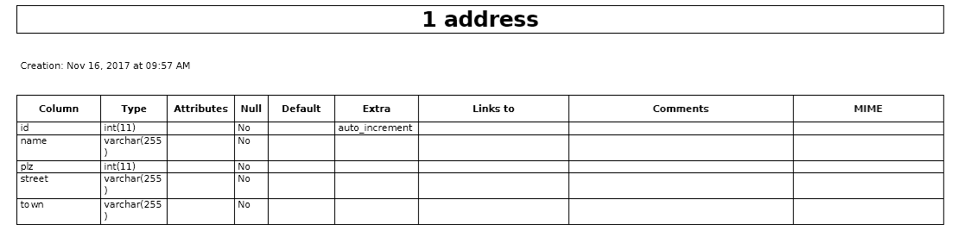

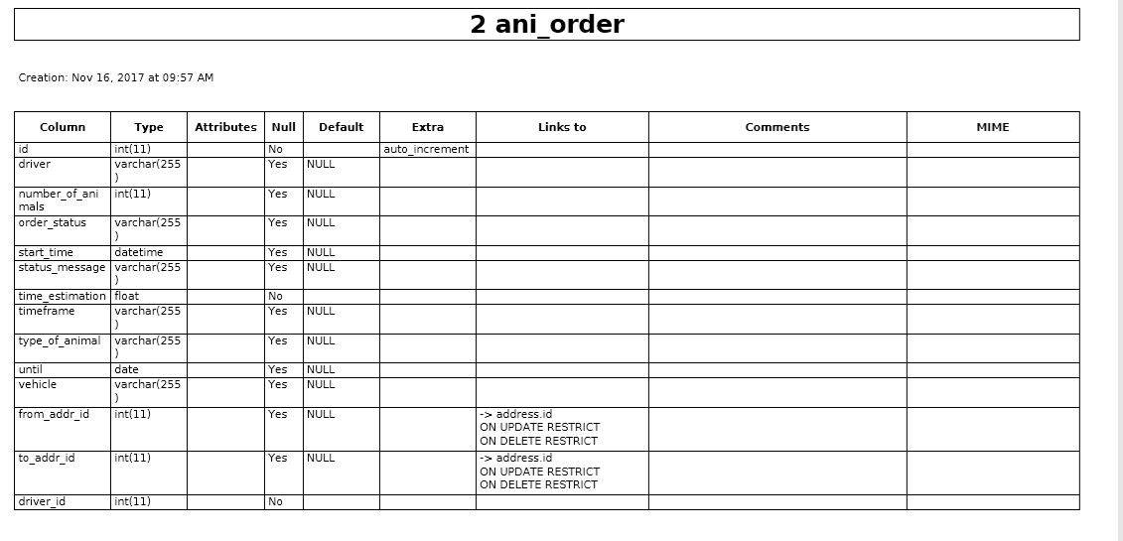

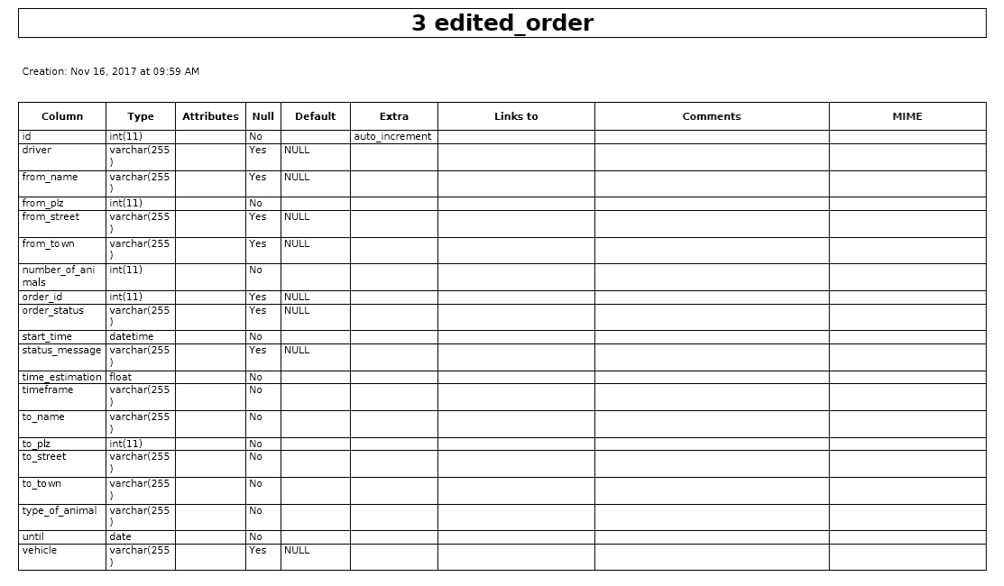

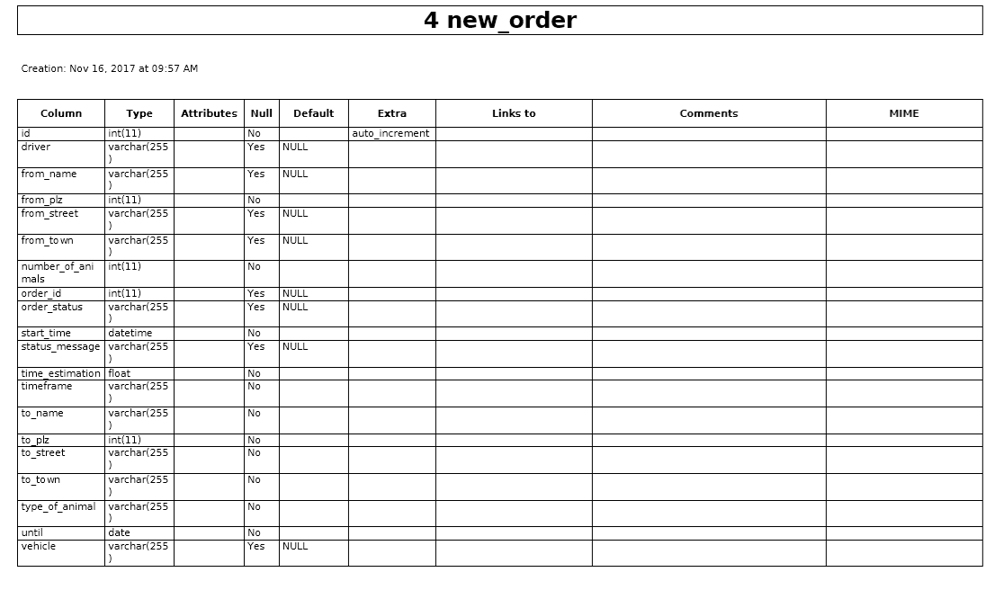

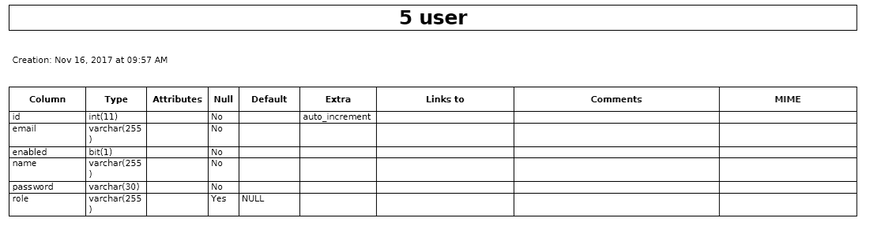

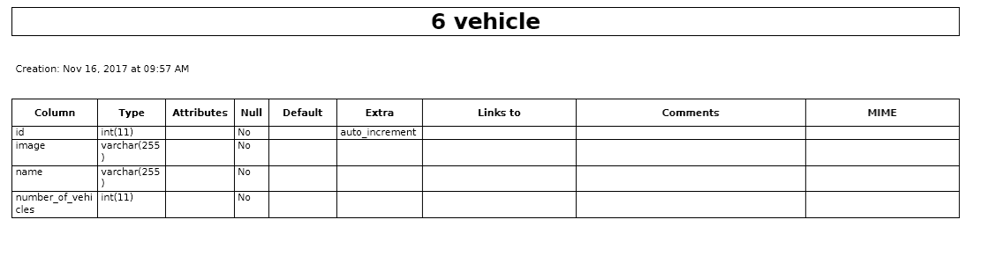

## 4.3 Software System Attributes

## 4.3.2 Availability

*.* Version 1

* The product shall be available for use between the hours of 8:00am and 5:30pm
* The product shall be capable of processing up 50 customers.
* uptime should be around 95% availability

Version 2

* The product shall continue to operate in local mode whenever it loses its link to the central server
* The product shall be capable of processing up to 500 within three years.

### 4.3.3 Security

* The user data is kept as securely as necessary. Especially the password is stored securely (using the [BCrypt](http://en.wikipedia.org/wiki/Bcrypt)BCryptPasswordEncoder from the Spring Framework, a hashing algorithm with randomly generated salt).

### 4.3.4 Maintainability

Version 1

* The product is expected to run under windows 10 and macOS High Sierra.

Version 2

* The maintenance releases will be offered to end-users once a year.
* Every registered user will have access to a help site via the Internet.
* The product shall be able to be installed in the specified environment within 2 working days.

Out of Scope

* The product might eventually be sold to a foreign market

### 4.3.5 Portability

* The application should run stable on the browsers Microsoft Edge and Apple SAFARI 11.0.
* The application should run stable on major OS systems (WINDOWS 10.0, macOS High Sierra).

### 4.3.6 Usability

Version 1

* The product shall help the user to avoid making mistakes
* The product shall make the users want to use it.
* The product shall be used by people with no training
* The product shall be easy for a truck driver to learn.
* The product shall use symbols and words that are naturally understandable by the user community.

Version 2

* The product shall conform to the Swiss Disabilities Act.
* The product shall allow the user to select a chosen language.